New Echota United Methodist Church Donation
to the Georgia National Guard Foundation
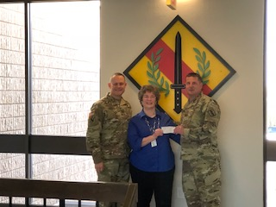
Each year, the New Echota United Methodist Church in Calhoun, Georgia, recognizes a non-profit charity as part of their special Veterans Day Service. This year the Georgia National Guard Family Support Foundation, Inc. was selected as the recipient of this generous offering.
MAJ Darrel Geving, member of the New Echota UMC and Executive Officer of the 781 CBRN of the Georgia National Guard, presented the $255.00 contribution to the Foundation on behalf of the congregation. COL Michael Maddox, Foundation Board Member for the 201st RSG, and Harriet Morgan, Program Manager for the Foundation, accepted the donation to Honor Veterans, past and present.
The Foundation provides emergency relief assistance to the Soldiers and Airmen of the Georgia National Guard facing financial hardships and greatly appreciates the support.

