July 10, 2021

U S Military Vets Motorcycle Club Cartersville Chapter Donates $1,600.00!

Despite a RAINY day in Georgia, a great group of veterans and supporters from all branches of the military visited the Clay National Guard Center on Saturday, 10 July 2021, to donate to the GA National Guard Foundation!

Throughout the year, their members organize fundraisers, raffles and rides in the North Georgia area and host annual parties with proceeds donated to charity organizations that serve the military. They work with the American Legion, the Veterans of Foreign Wars and other U S Military Vet MC Chapters. Since 2011, they have donated more than $13,000 to the Foundation to help Soldiers and Airmen of the Georgia National Guard faced with financial hardships.

This year, Maj Gen Tom “Gasket” Grabowski, BG Dwayne Wilson and CSM Jeff “Buckeye” Logan were able to meet with Harriet Morgan, Program Manager, to accept their generous donation in the amount of $1,600.00 from Clutch, Tonto, 2-Rona, E-T, Rawhide, Shoes, Dickens and Billy Mac!

We so appreciate the ongoing support and friendship from the current and previous members of the U S Military Vets Motorcycle Club that date back to 2011! THANK YOU TO ALL!

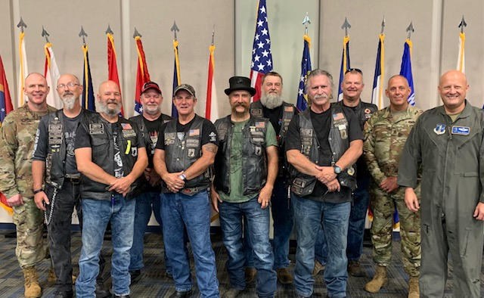

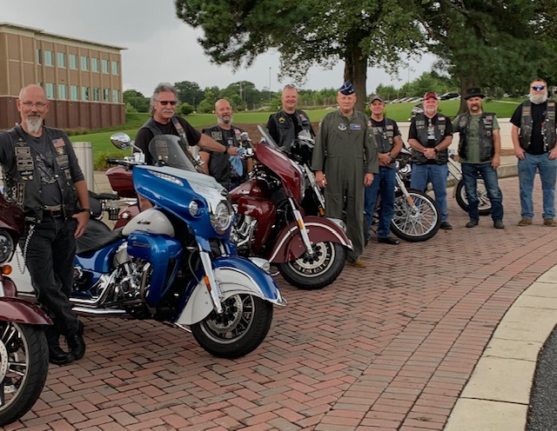

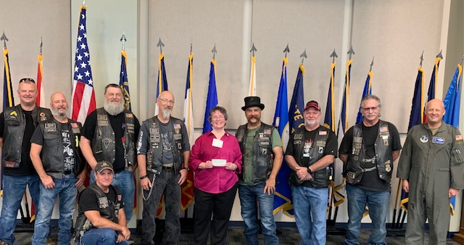“Billy Mc”, “Dickens”, “Shoes”, “Rawhide”, “E-T”, Yours Truly, “Clutch”, “2-Rona”, “Tonto” and “Gasket”

