How You Can Help

Sponsor A Child:
The cost to sponsor a child is only $1 per day, or, $365
annually. This provides warm lunches, boots, coats, medical examinations and needed medicines.

Provide A Scholarship:
Vocational school scholarships average $600 per year and university scholarships average $1,200 per year. Partial semester scholarships are welcome as well as full year tuition.

Go on A Mission Trip:
Join us as we interact with nearly 150 children on each journey participating in team educational programs, art and crafts, sports, lectures, mentoring, and lots of love and joy.
For future trips info: www.prumc.org/global-missions/georgia

Fund A Need/Project Hope & Love:
Help provide critical food supplies to families during Covid and high unemployment. Fund classroom supplies, playground equipment, special surgeries, firewood to heat classrooms, cleaning supplies, and much, much more! Any donation amount is appreciated!

For more information and how to donate:
Please visit our website www.georgiaforgeorgia.org or email info@georgiaforgeorgia.org

Why We Go to Georgia

When Peachtree Road United Methodist Church (PRUMC)
sent its first humanitarian aid team to Georgia in 1999, we
had no idea what to expect. But the team that year made
a commitment to themselves and to the Georgians that our
efforts would continue. Indeed, they have! Over the last 22 years we have sent hundreds of people and dozens of mission teams supporting the Georgian youth.

What began as basic renovation work at one school in the Imereti Region has now blossomed into a 12-month sustainable program encompassing two Preschool – 12th grade schools and one special needs school. We also have two full-time Georgian staff members who oversee all our efforts.

In 2017, with the support of PRUMC, Georgia for Georgia was formed, a non-profit 501(c)(3), which oversees our programs and closely monitors all aspects of our efforts in the country.
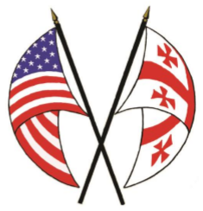
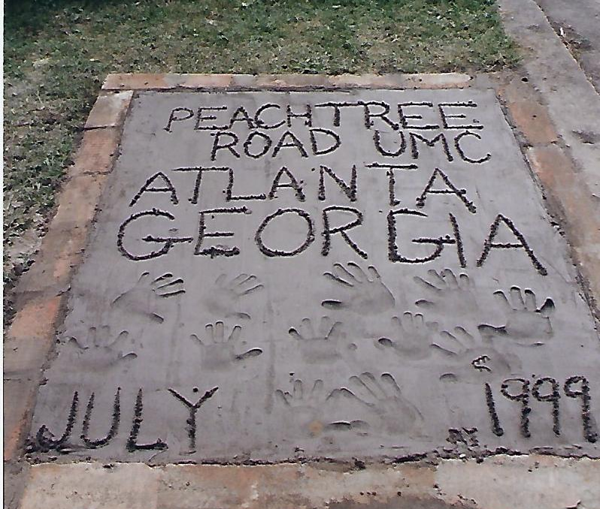

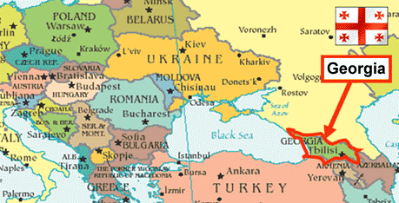
The country of Georgia, population 4 million is located in the Caucasus Mountains of Eastern Europe, east of the Black Sea, south of Russia and north of Turkey. Slightly larger than South Carolina, Georgia has one of the oldest languages (Kartuli) in the world along with its distinct alphabet.
On April 9, 1991 Georgia declared its independence from the Soviet Union and since then has been a democratic republic. Its history goes back before 1000 BC. Georgia has been invaded by many countries and empires, yet has maintained its rich culture, traditions, and religion. In 327 AD Georgia became the second nation in the world to establish Christianity as the official state religion. 88% of the population is Christian.

In August 2008, this small country was yet again invaded by their northern neighbor, Russia. Innocent children and thousands upon thousands of Georgians were forced to flee their homes. They now live as “internally displaced people,” and many of their children are in our schools and programs.

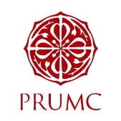
With the guidance of PRUMC, Sponsor A Child has been assisting 300+ children at three schools with life sustaining services. These include regular health examinations, follow up medical procedures, warm winter coats, shoes, essentials, and nutritional meals. For some, the lunch we provide will be their only meal of the day! Since the program began, children are much healthier, avoiding illness, remaining in school, keeping warm and maintaining a higher quality of life.
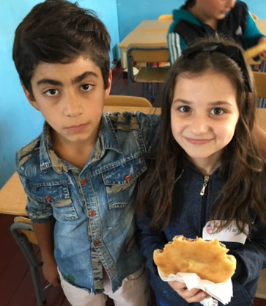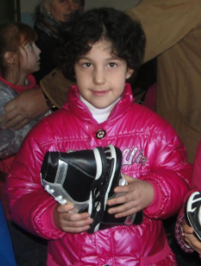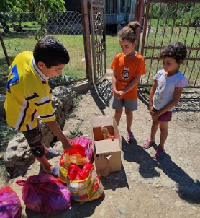
With Covid ravaging the Georgian economy and nearly all of our families facing unemployment and hardships, we launched Project Hope & Love in March 2020. Since then, we have been providing food and cooking oil to those affected in the schools we serve.

Thanks to our efforts over the years, we have witnessed and learned of so many wonderful success stories…Peer to peer mentoring, community volunteer projects, graduates advancing to higher education and now Georgians giving back to each other!

