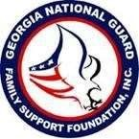
The Georgia National Guard Foundation and the Atlanta Hawks!
TEAMING UP again for the 2019-2020 Hawks Season at the newly renovated State Farm Arena!
The arena now offers TopGolf Swing Suites, Courtside Club/Bar, Zac Brown Social Club, The Swag Shop, Beer Hall, CFA Fan Zone, new dining options and 12,500 renovated seats!
With the new draft picks in Cam Reddish and De’Andre Hunter, the veterans in Vince Carter (last season!) and Jabari Parker, and budding stars in Trae Young, John, Collins, and Kevin Huerter, we are fired up!
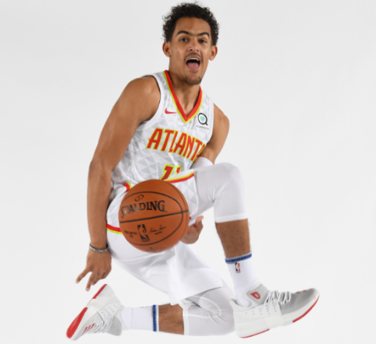

Don’t miss out on the opportunity to cheer on your Atlanta Hawks
at Start Farm Arena for an exciting 2019-20 season!

To take advantage of exclusive discounts throughout the year
Please copy and paste link to your personal computer browser!

https://oss.ticketmaster.com/aps/hawks/EN/link/promotion/home/816570a4b680e2b9b0a199cea08a61e9725c2c7b

Promo Code: GUARDFAMILY
**Ticket prices and availability are subject to change.
Tickets do sell out, so order TODAY! Sales are final, no refunds or exchanges.

Questions or interested in a group outing? Please contact our dedicated Hawks rep: LUKE WILLS
Phone 404.878.3846 Email luke.wills@hawks.com

A portion of each ticket purchased through this link will be donated to the
Georgia National Guard Foundation!

Thank you for your support!!

