The ATLANTA HAWKS
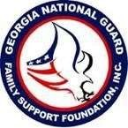
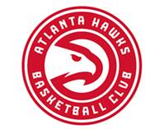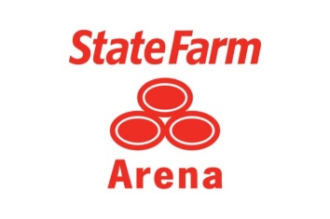
The Georgia National Guard Foundation

TEAMING UP for the 2018-2019 Hawks Season at the newly renovated ($192.5 Million) State Farm Arena! The 2019 Atlanta Hawks are back and winning games left and right! Click the link below to take advantage of exclusive discounts for January – April games. If you do not see the game(s) listed that you are interested in, please contact Luke Wills at luke.wills@hawks.com or at 404-878-3846 to order by phone.

Please COPY AND PASTE LINK TO YOUR PERSONAL COMPUTER:
hawks.com/gaguardfamily < hawks.com/gaguardfamily >

Access Code: GAGUARDFAMILY (Please open the link above from a computer using Google Chrome)

Ticket prices and availability are subject to change. Tickets do sell out, so order TODAY! Tickets will sell out, so order TODAY! Sales are final, no refunds or exchanges.

Interested in sitting closer? Please contact:
Luke Wills | 404-878-3846 | luke.wills@hawks.com < Caution-mailto:ryan.coller@hawks.com >

The arena now offers TopGolf Swing Suites, Courtside Club/Bar, Zac Brown Social Club, The Swag Shop, Beer Hall, CFA Fan Zone, new dining options and 12,500 renovated seats with extra legroom and cup holders!

Kevin Huerter, Trae Young and Omari Spellman

A portion of each ticket purchased through this link will be donated to the
Georgia National Guard Foundation!

Thank you for your support!!

